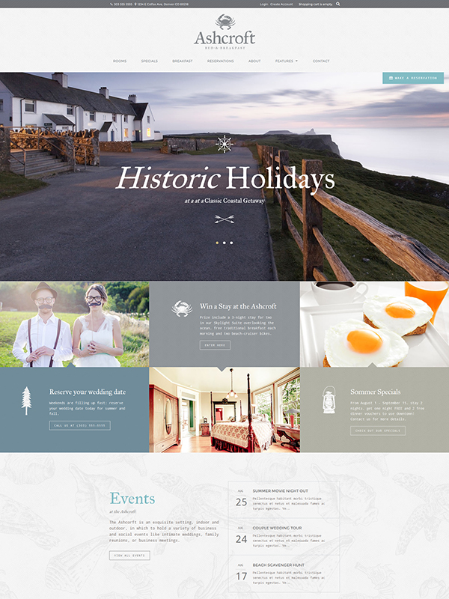 | Website Features  - Mobile and Tablet Optimized  - Homepage Slideshow  - Rooms Web App  - Integrated Google Calendars for Availability  - Specials Web App  - Multiple Layout Options  - Lead Generation Form  - Ecommerce  - Google Maps  - Secure Zone  - Foundation 5 Components  Price: $XXXX.XX

